Asif subhan, Ricky Sanders, Evan Simmons, Meng Qi

asubhan@uncc.edu

Abstract

The purpose of this document is to explain each part of the website in details

USER MANUAL for ADMIN PAGE

Instructions for how to use X Note Plus

Contents

Admin Page intro 2

Dashboard 2

Accounts 2

View 3

ADD 3

Notes Files 4

Files 4

Study Guide 5

Abuse 6

Files 6

Study Guide 6

Feeds 7

View 7

Add 7

# Admin Page

The admin is a tool for Admins and Teachers to take a look at the status of the website. It provide the information needed to run the website smoothly. There are some features as described this manual that requires admin access. You can use the following account that already has admin access to test this feature:  
Username: Ricky  
Password: pass

# Dashboard

Dashboard is a simple page that shows the number of files with low rating or rated abused.

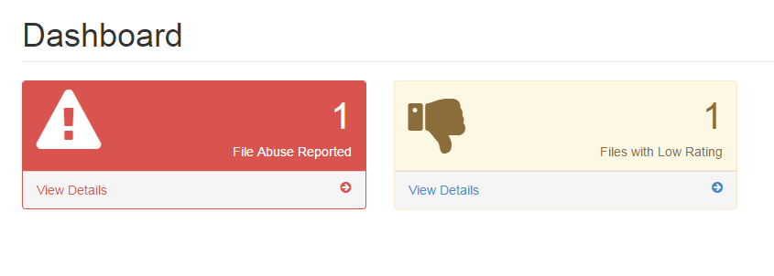

# Accounts

Admin can view and add user accounts via the left side menu. There are two types of accounts, admin and student.

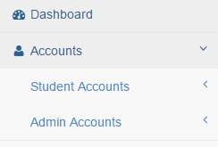

Within either Student or Admin Accounts, the admin can choose to either view or add accounts. When viewing accounts, the admin can see general information about the account and has the option to delete an account or edit the user’s profile.

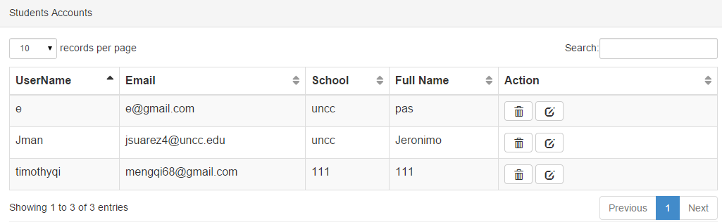

## View

Above is a picture of the view for student accounts. You can delete an account using the  button and the account can be edited using the  button.

## ADD

If you select the Add account option you will get a screen that displays the table below.

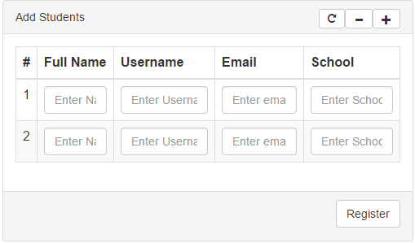

The admin can add one or more users here. Pressing the  button resets the table, pressing the  button to remove users, and the  button to add another user. You should only enter usernames that do not already exist within the database to avoid problems or having to retype the information to add the users.

# Notes Files

When an admin selects the Notes Files from the left navigation bar they are presented with the option of either viewing user files or study guides.

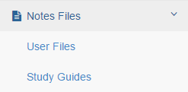

## Files

Under the user files the admin can select the  button to delete a note file or select the  button to view the note file. There is also a search bar for live searches through the documents.

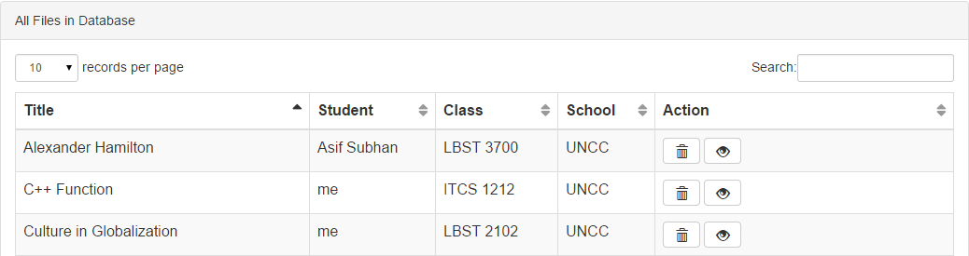

## Study Guide

If the admin select the Study Guides option they are presented with the following screen that has a  button for viewing the study guides.

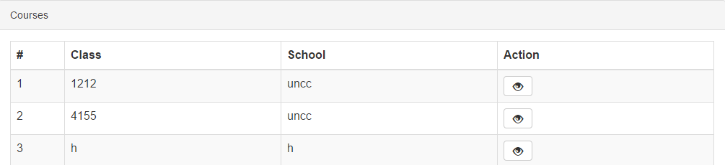

When the admin selects the view button for a study guide they are presented with the study guide for that course as if they were viewing it as a student, but the admin can see the rating for each sentence and delete or edit a sentence. As shown below.

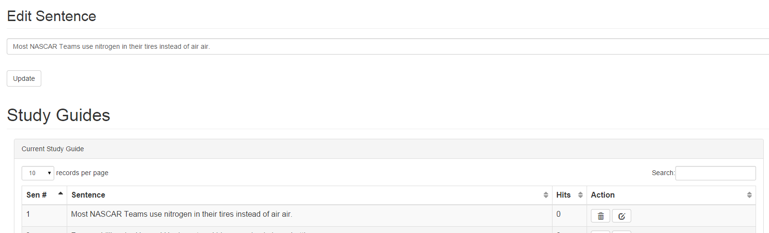

# Abuse

The abuse page has two parts as well. Admin can see the abused reported for files as well as for each sentence on study guide.

## Files

As showing the figure below, the Admin can delete the files reported to be abused

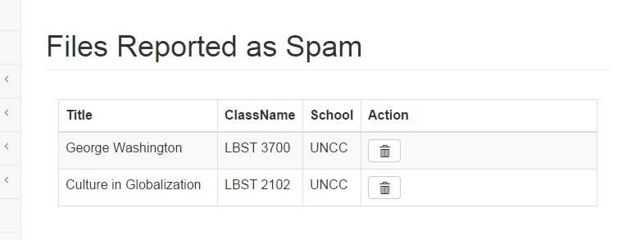

## Study Guide

The study Guide abuse page same as file abuse. The Admin can only delete abused sentence not edit in abuse section.

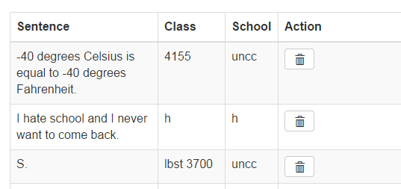

# Feeds

Feeds are shown on the homepage of the student page. The Admin can view, edit, add and delete feeds.

## View

On this page the user can either delete a feed or edit it. The date will be automatically replaced when feed is updated.

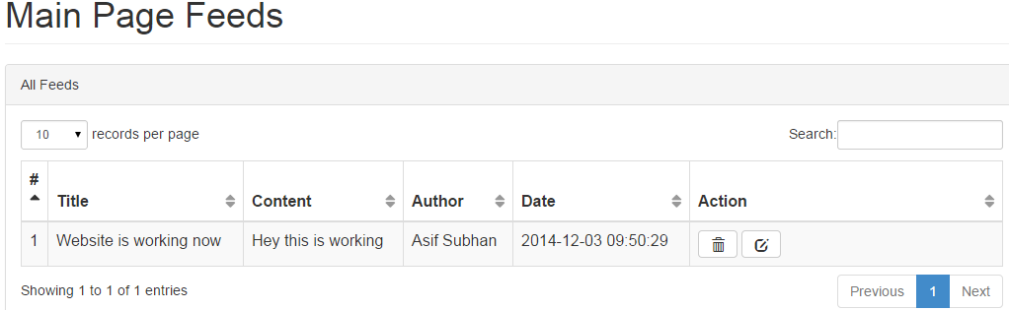

## Add

Here the Admin can add a new feed. The website automatically add the date and the Admin name in the database. The website doesn’t allow the admin to change his/her name in the feeds section.

